Welcome to our practice!
Please help us serve you better by taking a few minutes to provide the following information.

Name: |  |  |  |  | Today’s date:
 | Last Name | First Name
Address:
City:
State:
ZIP:
Phone:
 | mobile |  | home |  |  | work
DOB: |  |  | Age: |  |  | Gender: |  |  | M |  | F
Email:
Occupation: |  |  | Marital status: |  |  | M |  | S |  | W |  | D
Employer:
Emergency Contact:
Name: |  |  | Phone:
Primary Care Physician
Name: |  |  | Date of next visit
Specialist Physician
Name: |  |  | Date of next visit

How did you hear about our practice?
Who can we thank for referring you to our practice?

The following is very important in our evaluation process.
Please fill out these forms as specifically as possible to provide us with a clear picture of your present pain and functional status.

What is the primary issue/problem that brings you in today? | Please shade in areas where you have pain, discomfort, or tension.  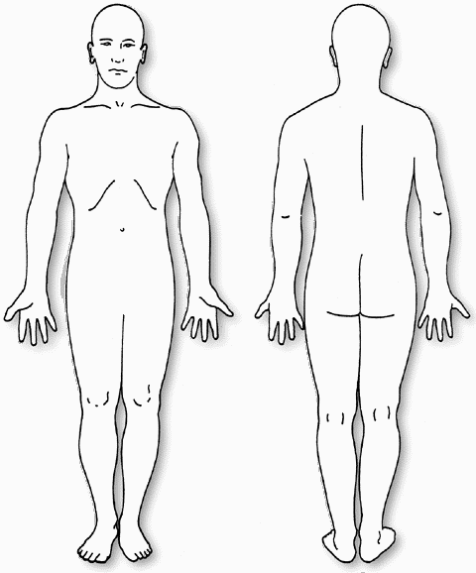
Secondary concern/problem?
As a result, I am now having difficulty with:
Are you currently experiencing pain as a result of these symptoms? If yes, what is it like?
When did your symptom(s) begin?
Date:

Please rate your pain in the last 24-72 hours  Using the “0 -10” scale where 0 is no pain and 10 is the worst possible pain. | At its worst
 | At its best
 | At present
 | Night (sleeping)

At what time of day are your symptoms the worst?
At what time of day are your symptoms the best?
What activities increase your pain?
What activities decrease your pain?

What other types of treatment have you had for this problem?
 | Massage |  | Bodywork |  |  | Physical Therapy |  | Myofascial Release |  | Chiropractic |  | Surgery
Other Medical Treatment: (Please Describe)

Check the box if you have had any of the following medical conditions?
 | Diabetes |  | Lung disease |  | Weight change |  | Varicose veins |  | Neurological problems |  | Pregnancy
 | Rheumatic fever |  | Osteoporosis |  | Migraine headaches |  | Epilepsy / seizures |  | Stroke |  | Blackouts
 | Heart Murmur |  | Malignancy |  | Arthritis |  | Broken bones (fracture |  | Metal implants |  | High blood pressure
 | Circulatory problems |  | Liver disease |  | Heart disease / pacemaker |  | Kidney disease |  | Others (explain below)

List past medical history and dates of occurrence. Include surgeries, accidents and other traumas.
List ALL medications which you are currently taking, the condition for which you are using them, the dose, and their effectiveness. (Include supplements, herbal and homeopathic remedies).
Medication | For treatment of | Dose / Amount per day | Effectiveness

Do you smoke? | Yes |  | No |  | If “Yes” – How much?
When did you quit? |  |  |  |  | If not, Would you like to quit?
Is there a chance you may be pregnant at this time? |  |  |  |  | Yes |  |  | No
Do you engage in regular exercise? |  |  |  |  |  |  |  |  | Yes |  |  | No
What type and how often?
Are you able to exercise now? |  |  |  |  |  |  |  |  | Yes |  |  | No
Do you have discomfort, shortness of breath, or pain with exercise? |  |  |  |  |  |  |  |  | Yes |  |  | No
Please Describe:
In general, your lifestyle is: |  | 1 |  | 2 |  | 3 | 4 |  |  |  | 5
 |  | Active |  |  |  | Average |  |  |  |  | Inactive

If sleep is a problem, answer these questions:
Do you have trouble falling asleep? |  | Yes | No
Is your sleep restful? |  | Yes | No
Do you find it difficult to lie down? |  | Yes | No
Do you find it difficult to change positions in bed?
How many times do you wake in the night?
How long before you fall back to sleep?

List all the Tasks / Activities that you have difficulty performing and your tolerance (minutes/hours).
If you are no longer able to perform an activity, your tolerance would be “0”.
Task / Activity |  |  | Tolerance (minutes/hours)
I walk for |  | minutes before needing to rest
I stand for |  | minutes before needing to sit
I sit for |  | minutes before needing to change positions/get up

Do you have trouble getting up from a chair? | Yes | No
Do you have trouble putting on your shoes and socks? | Yes | No
Do you have difficulty climbing stairs? | Yes | No

Patient Goals
Please list the activities that you would like to be able to do as a result of therapy.
Task / Activity | Duration / How Often | By When
Other Goals?

I understand that Adam Field Physical Therapy will maintain my privacy to the highest standards and may use or disclose my personal health information for the purposes of carrying out treatment, obtaining payment, evaluating the quality of services provided and any administrative operations related to treatment or payment.

I do hereby agree and give my consent for Adam Field Physical Therapy to furnish care and treatment that is considered necessary and proper in the diagnosing or treating of my physical condition.

I understand that I retain the right to revoke this consent by notifying the practice in writing at any time.
I hereby certify that all the above information is true to the best of my knowledge.

Patient/Parent/Guardian Signature: _______________________________ Date: ___________

